**Task 2. Create a New IAM User Named "S3-User":**

1. Create a new IAM user with programmatic access.
2. Attach the AmazonS3FullAccess policy to the user.
3. Generate an access key and secret key for the IAM user.

1. Open the IAM console:

* Go to the AWS Management Console and search for "IAM".

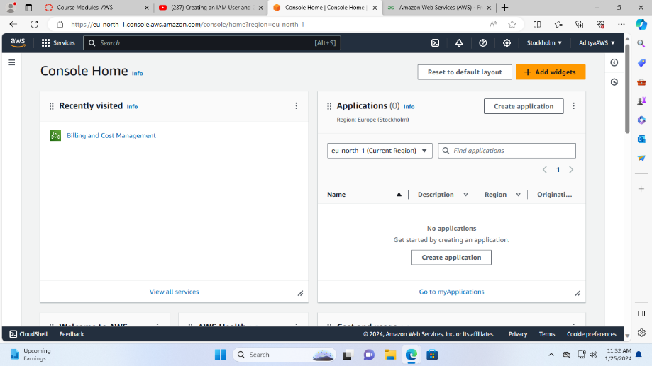

* Click on "IAM" to open the service.

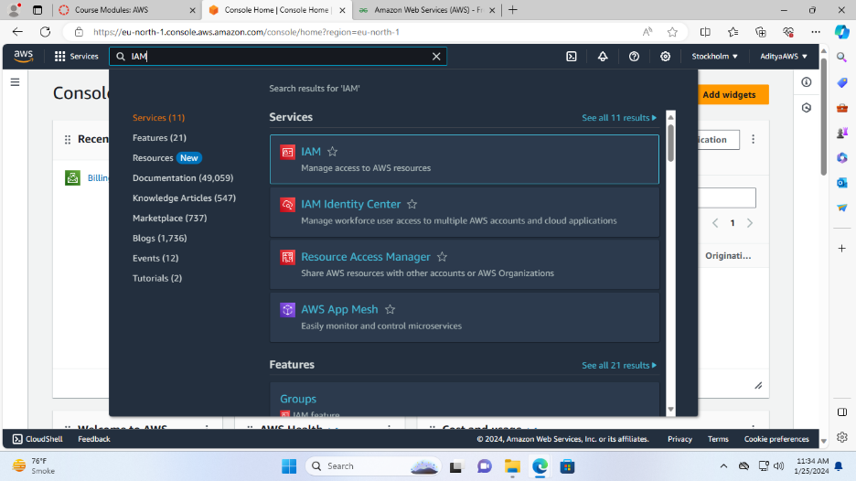

2. Create a new user:

* In the IAM console, click on "Users" on the left side menu.

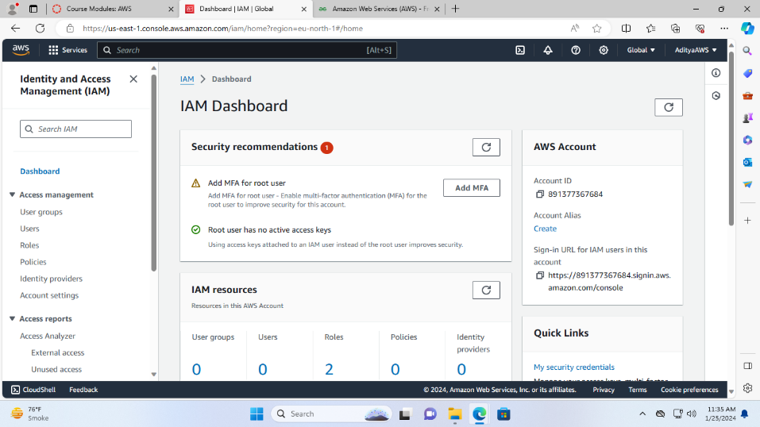

* Click on "Add users".

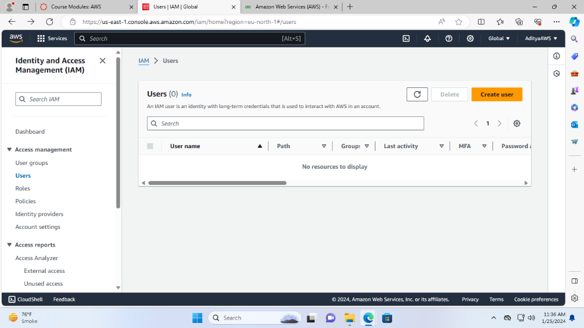

* Name the user as “**S3-User”** and do not check any box just continue as we are creating user with programmatic access. Click “Next”.

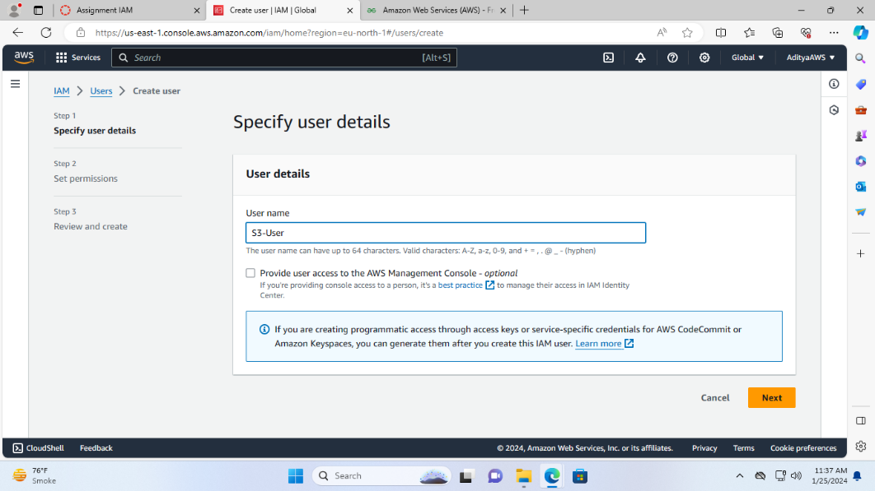

3. Set permissions:

* Now, select Attach policies directly

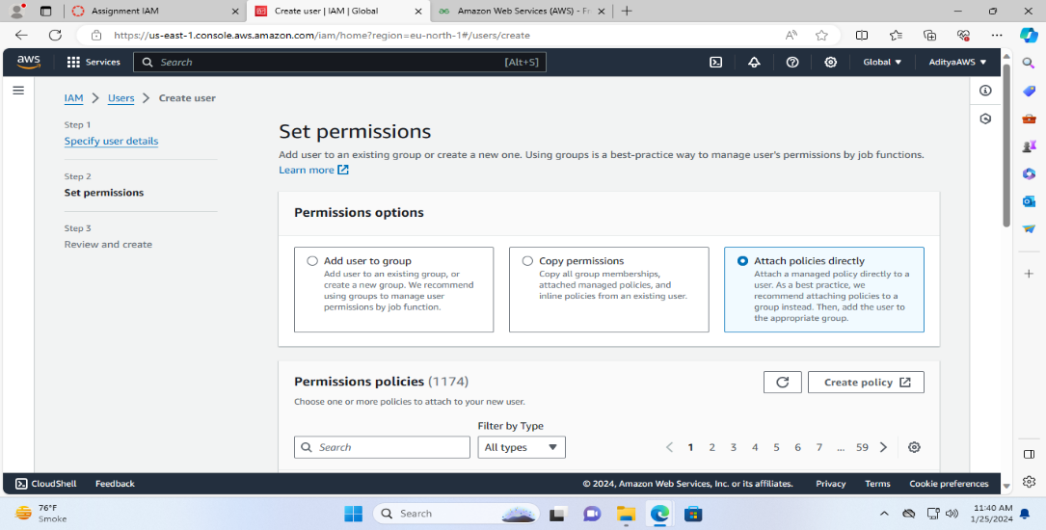

* Search AmazonS3FullAccess in the permissions policies and check the box to add the policy.
* Click "Next".

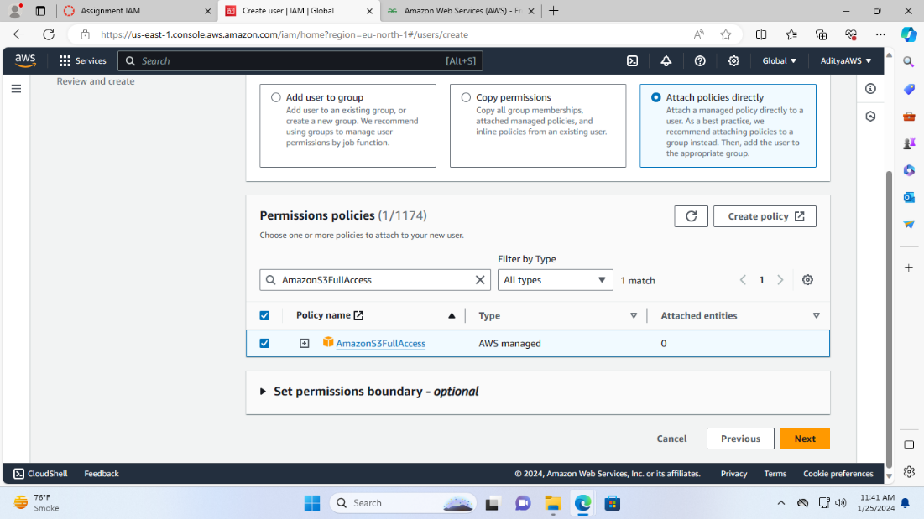

4. Review and create:

* Now review your choices and check the details.

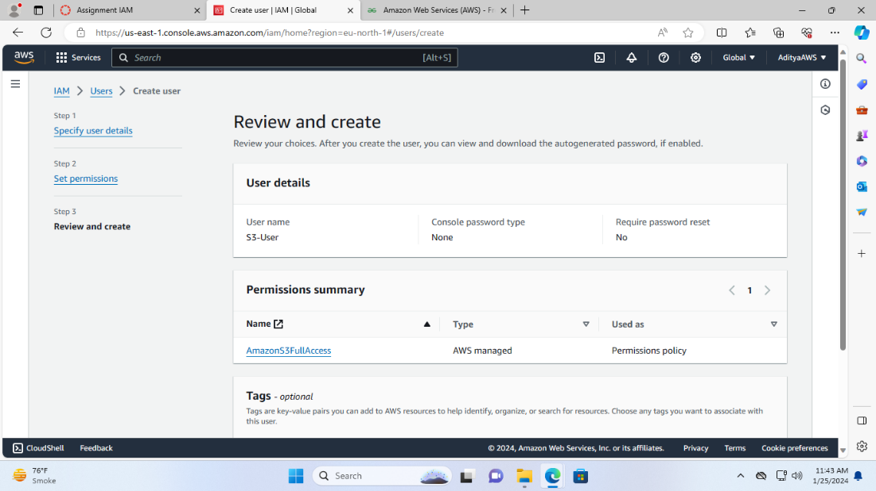

* Click “Create user”.

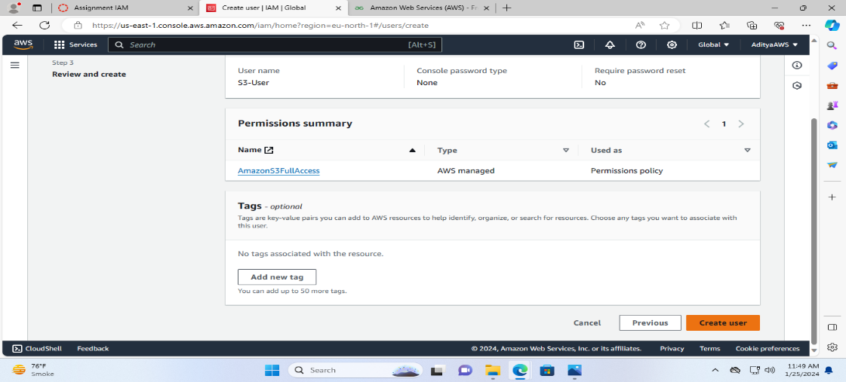

User is created successfully with the policy AmazonS3FullAccess,

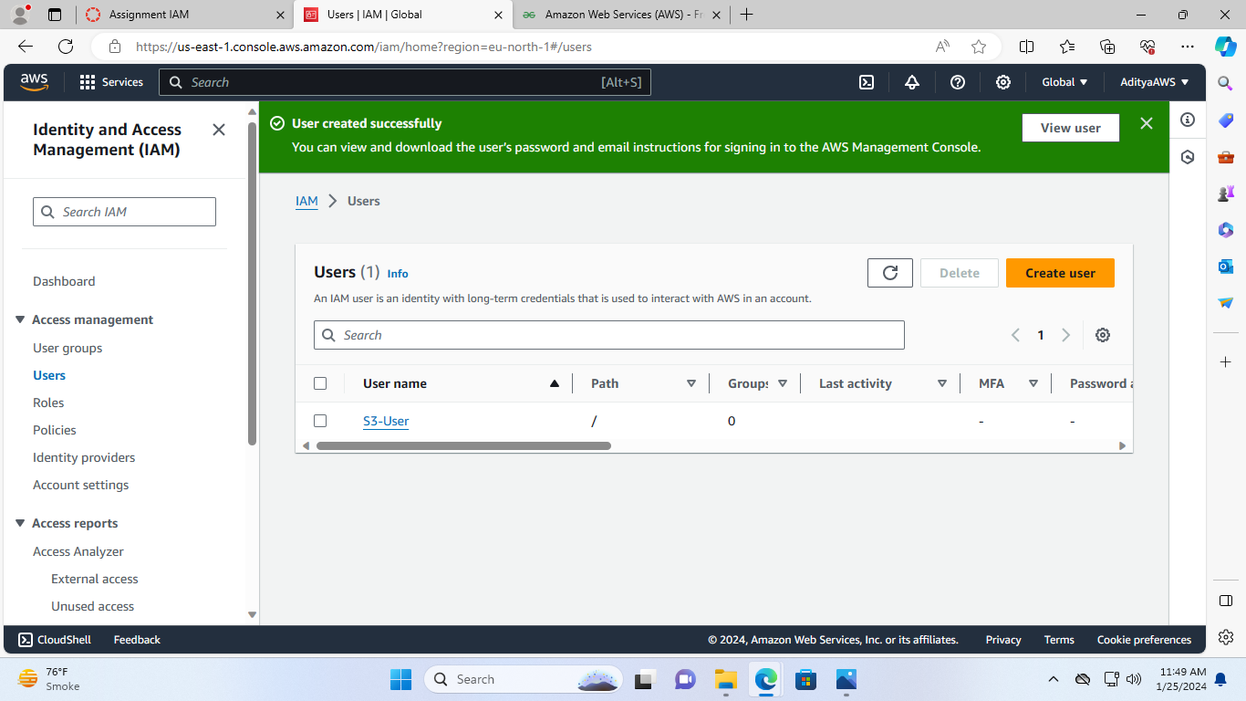

Now, In order to generate an access key and secret key for the IAM user.

* 1. Click on the user, we have created

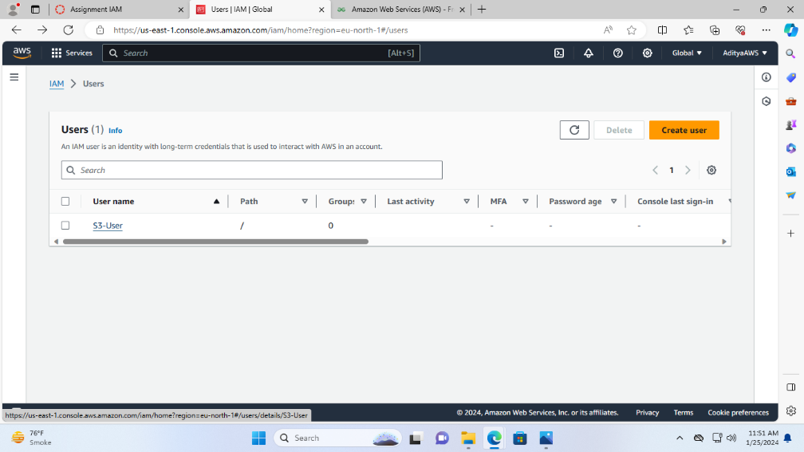

It will redirect to the User info:

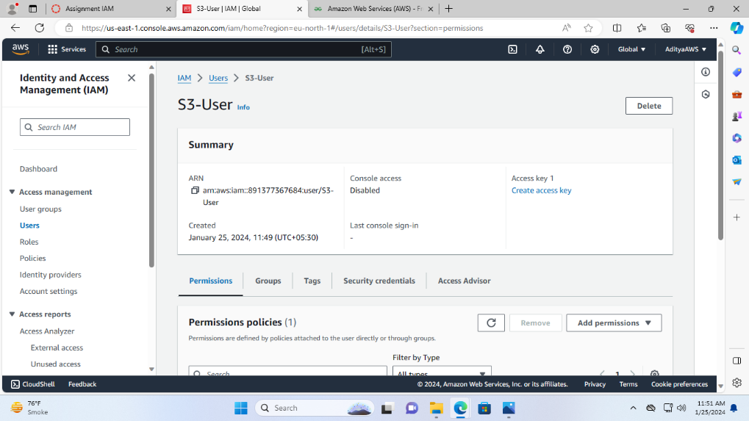

* 1. Then, click on the security credentials.

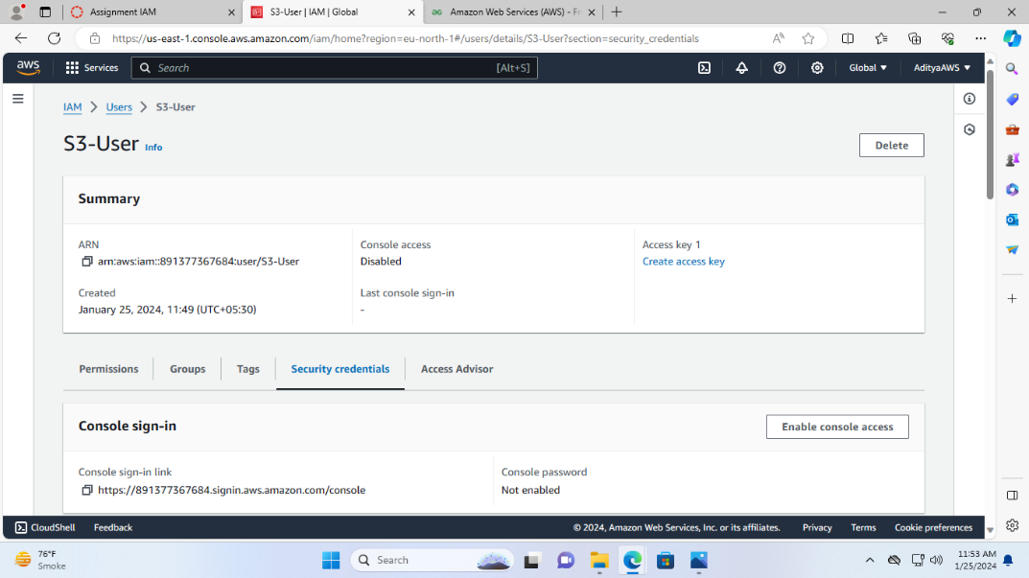

* 1. Under security credentials click on the “Create access key”.

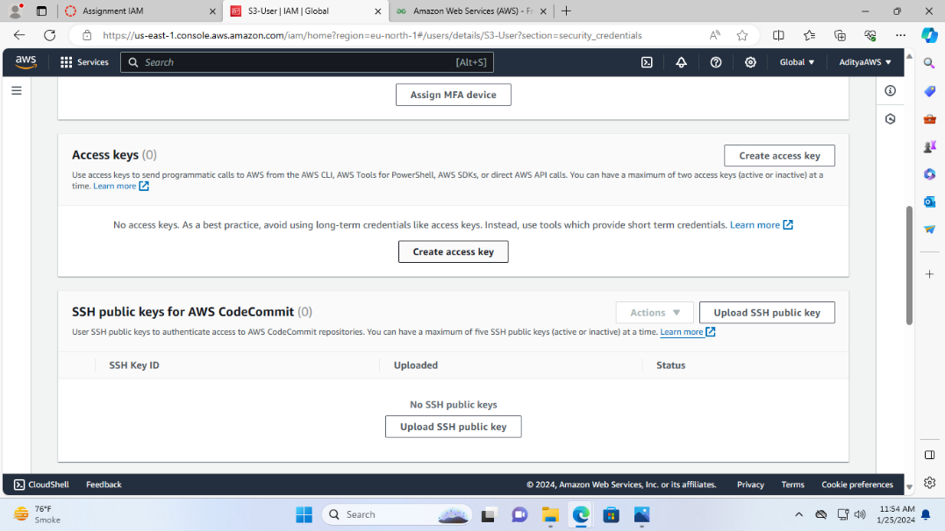

* 1. Select CLI

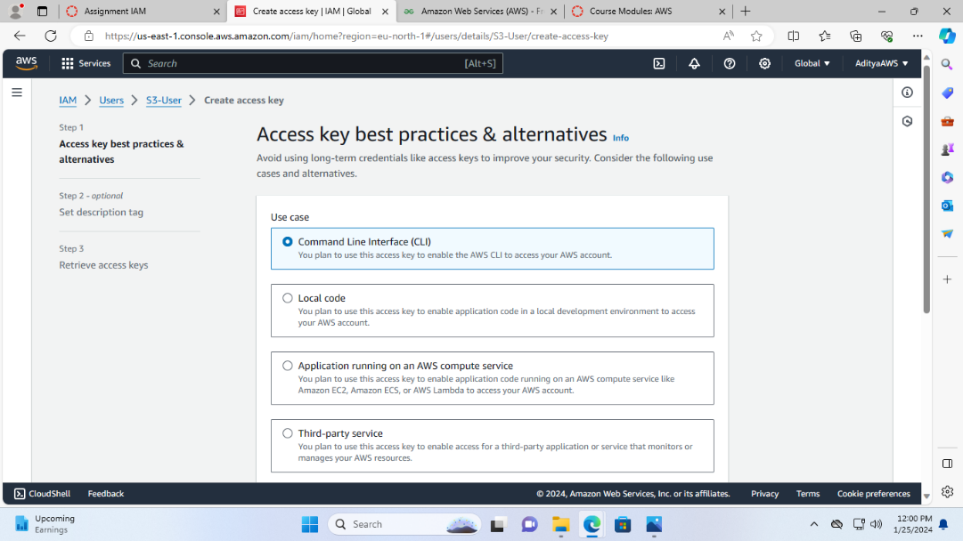

* 1. Check the consent box and click “Next”.

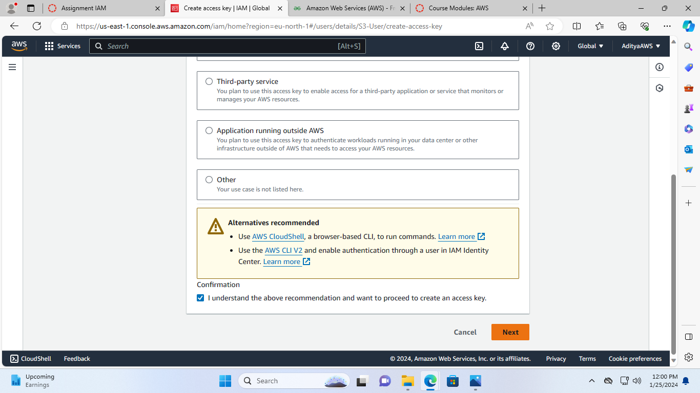

* 1. If you want set description tag then add, otherwise it is optional and click “ Create access key.

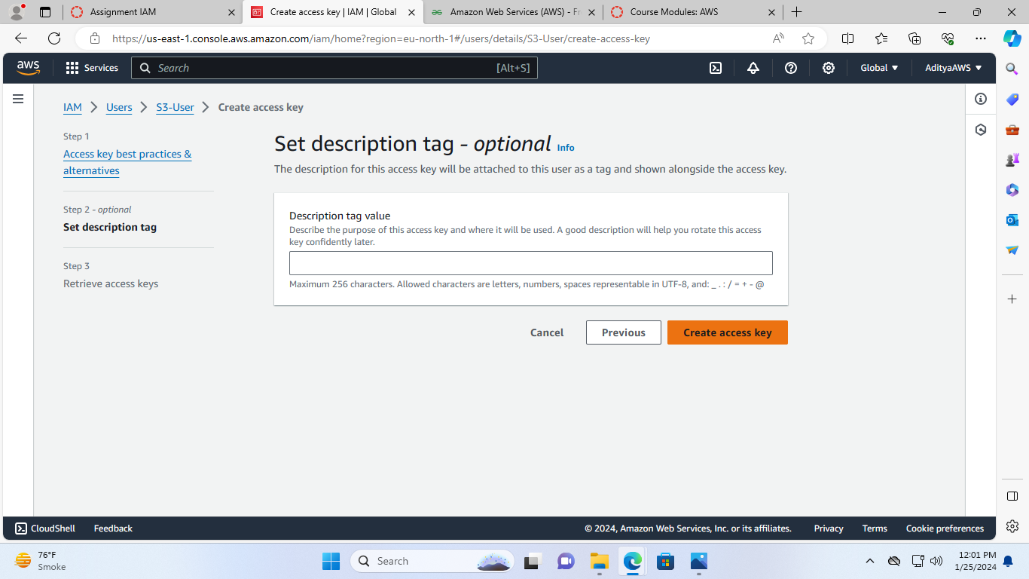

Now, the access key is generated and this is the only time that the secret access key can be viewed or downloaded. You cannot recover it later. However, you can create a new access key any time. Download the csv file, keep it safe and do not share.

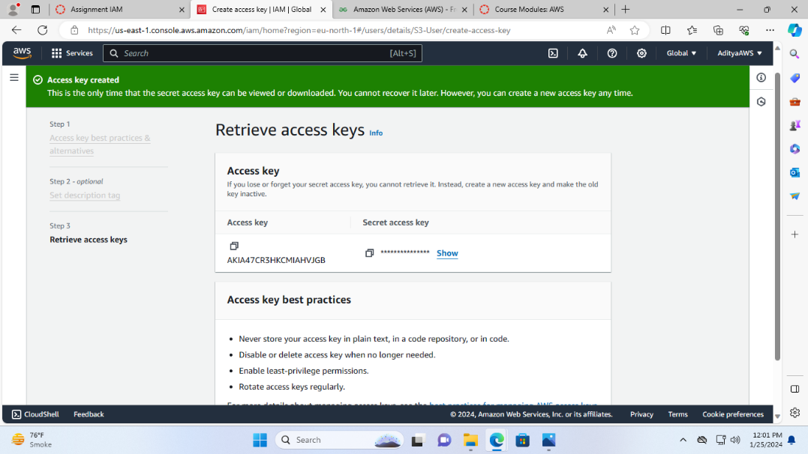

Click “Done”

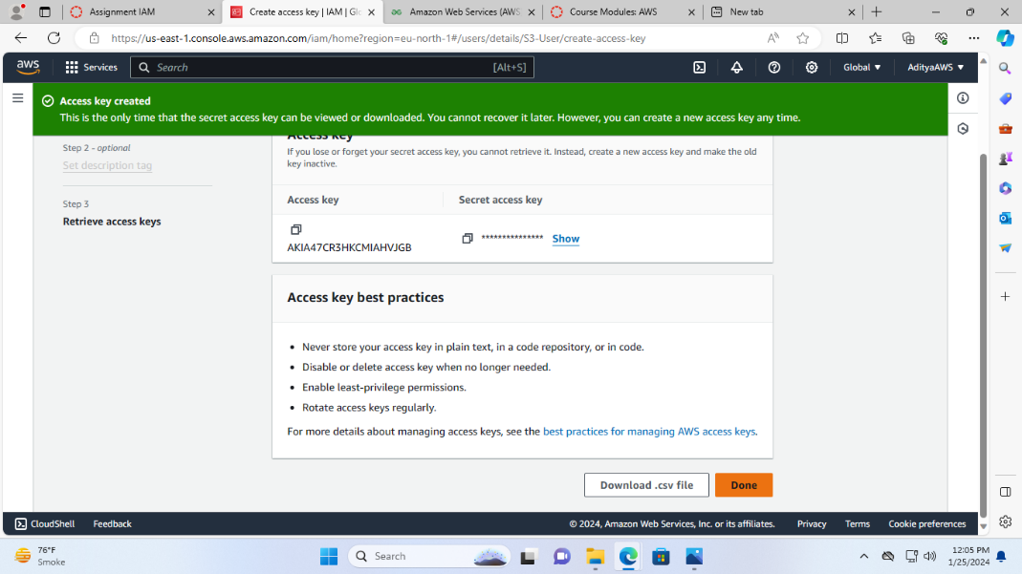

And You can see in the user info the access key 1 is active.

